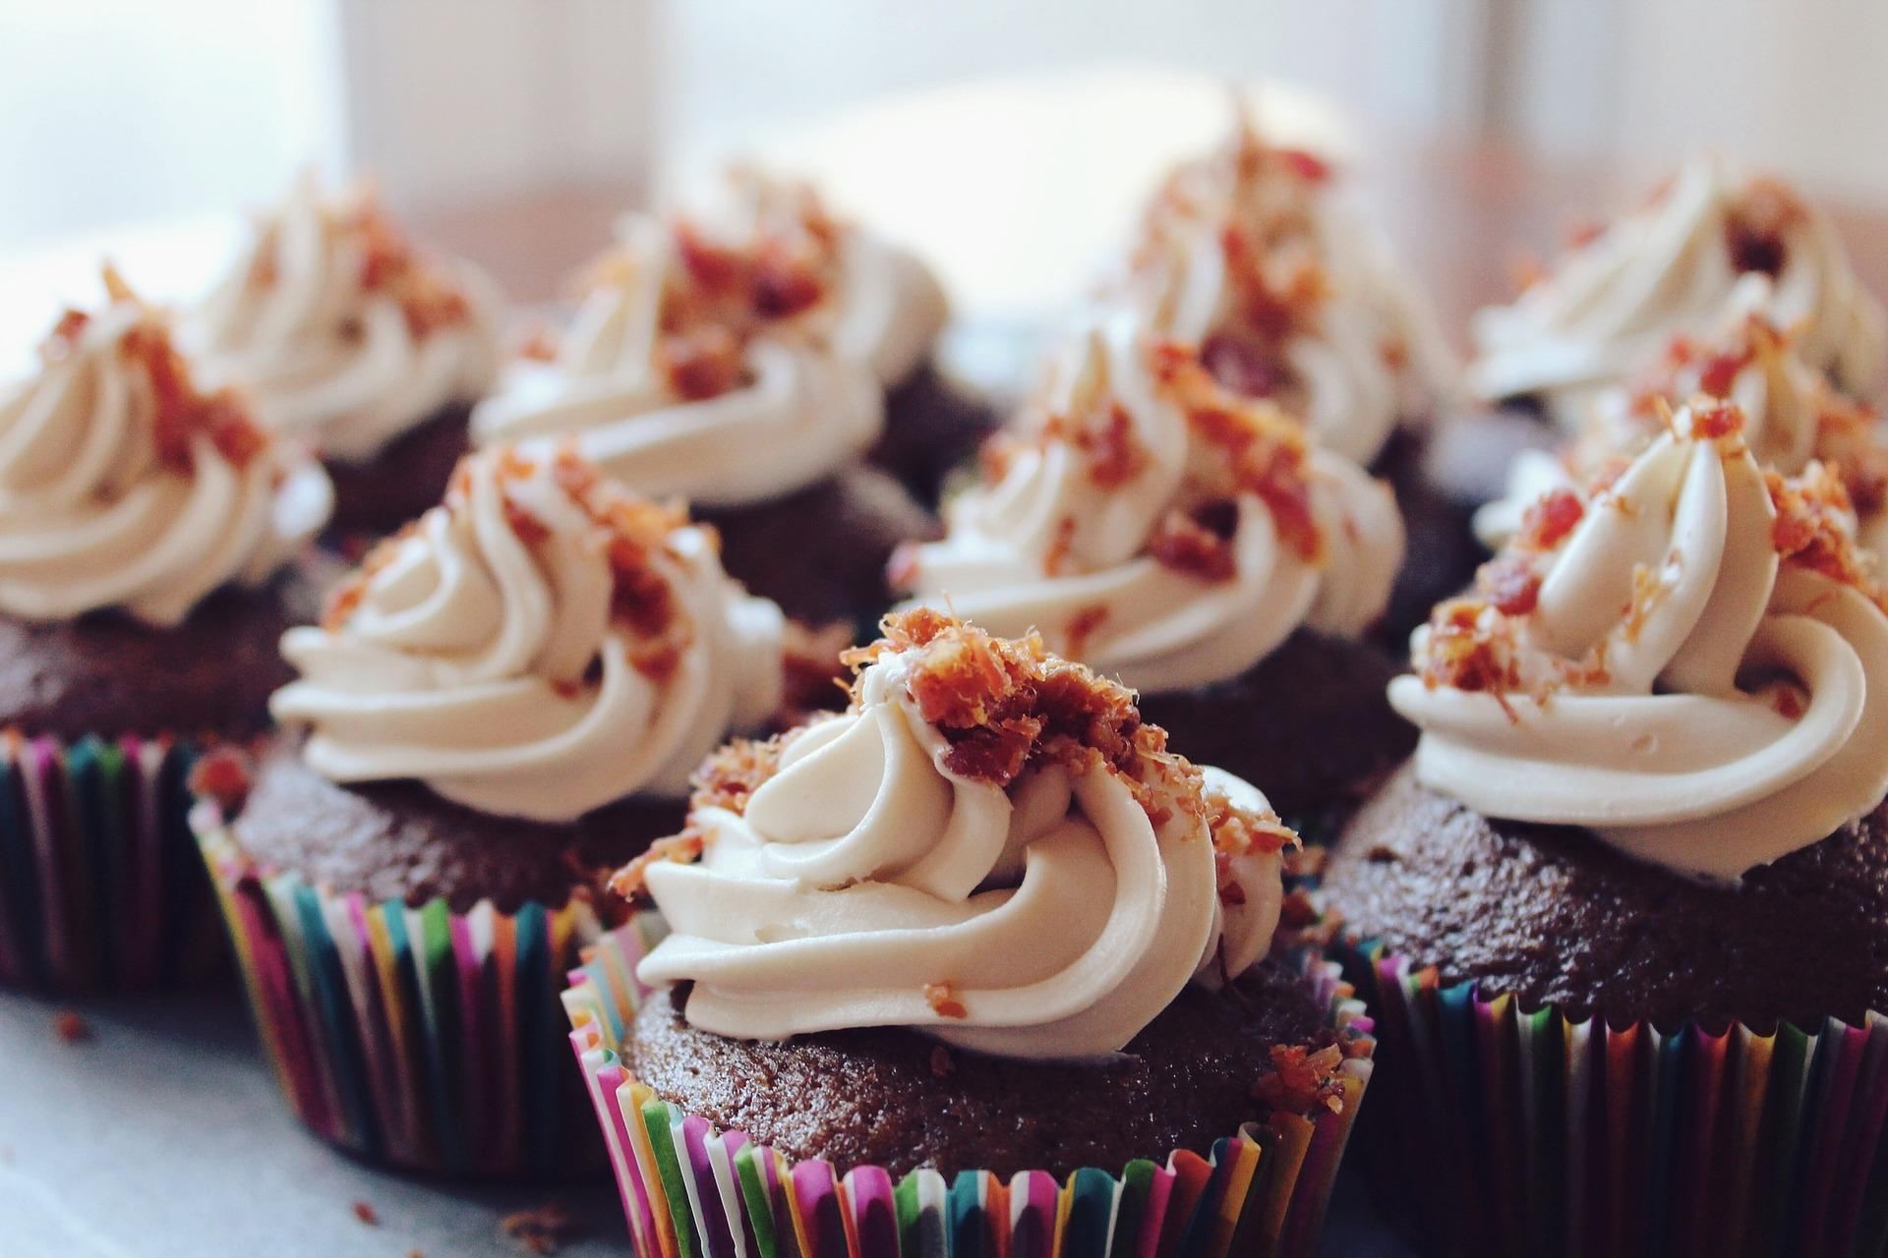
Cake Sale
We are selling cakes on Friday 15th September between 2:00p.m. and 3:00p.m.
We hope to see you there

Cupcakes
Flapjacks
Chocolate Brownies

We will be selling

Come and join us in the year 4 classroom and buy some of our delicious cakes.

